Sprint 3 Plan, Civic Duty, Team Civic Duty, Sprint Completion 07/24/18, Revision 1, Revision Date 07/16/18

*Goals: Be able to integrate all UI’s into React Native and be able to display information*

**User Stories:**

***User Story 1:***

As a registered voter, I want to be able to browse the candidates/representatives

* + *Task 1:* Be able to click on desired candidate/representative (5)
  + *Task 2:* Be able to display candidate/representative information (5)
  + *Task 3:* Create a React Native page for the user to input their information (5)
  + *Task 4:* Have the user information be able to return their representatives (8)

*Total hours for user story 1:* 23 hrs

***User Story 2:***

As a non-registered voter, I want to be able to know how to register so I can vote in the next election.

* + *Task 1:* Implement voting instruction page (5)
  + *Task 2:* Implement ability for user to input their information (8)

*Total hours for user story 2:* 13 hrs

***User Story 3:***

As a registered voter, I want to be able to view each House of Representatives member so that I can get a better view of who represents me in the House of Representatives.

* + *Task 1:* Create a skeleton page for representatives (5)
  + *Task 2*: Populate the representative page with information (8)

*Total hours for user story 3:* 13 hrs

***User Story 4:***

As a developer, I want our API endpoints to be more intuitive so that it is easier to write clean code on the frontend.

* + *Task 1:* Refactor code (8)

*Total hours for user story 4:* 8 hrs

**Team Roles**

*Nick:* Frontend developer

*Daniel:* Frontend developer

*Rob:* Frontend/Backend developer

*Rui:* Frontend developer, Scrum Master

*Bryan:* Frontend developer, Scrum Master

**Initial Task(s) Assignment**

*Nick:* user story 1, task 1, 2; (10)

*Daniel:* user story 2, task 1, 2; (13)

*Rob:* user story 3, task 1, 2; (13)

*Rui:* user story 1, task 4 ; (8)

*Bryan:* user story 1, task 3; user story 4, task 1; (13)

**Initial Burnup Chart**

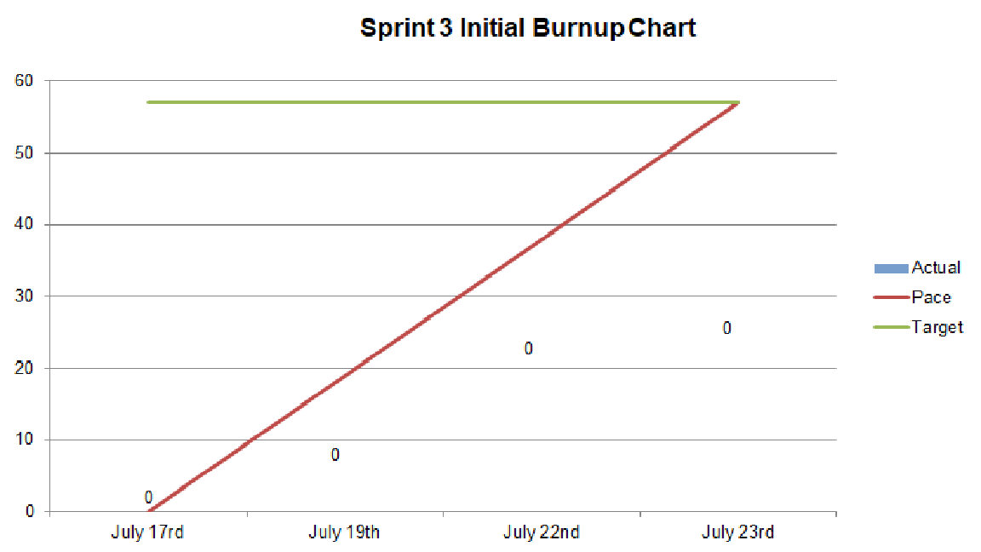

**Initial Scrum Board**

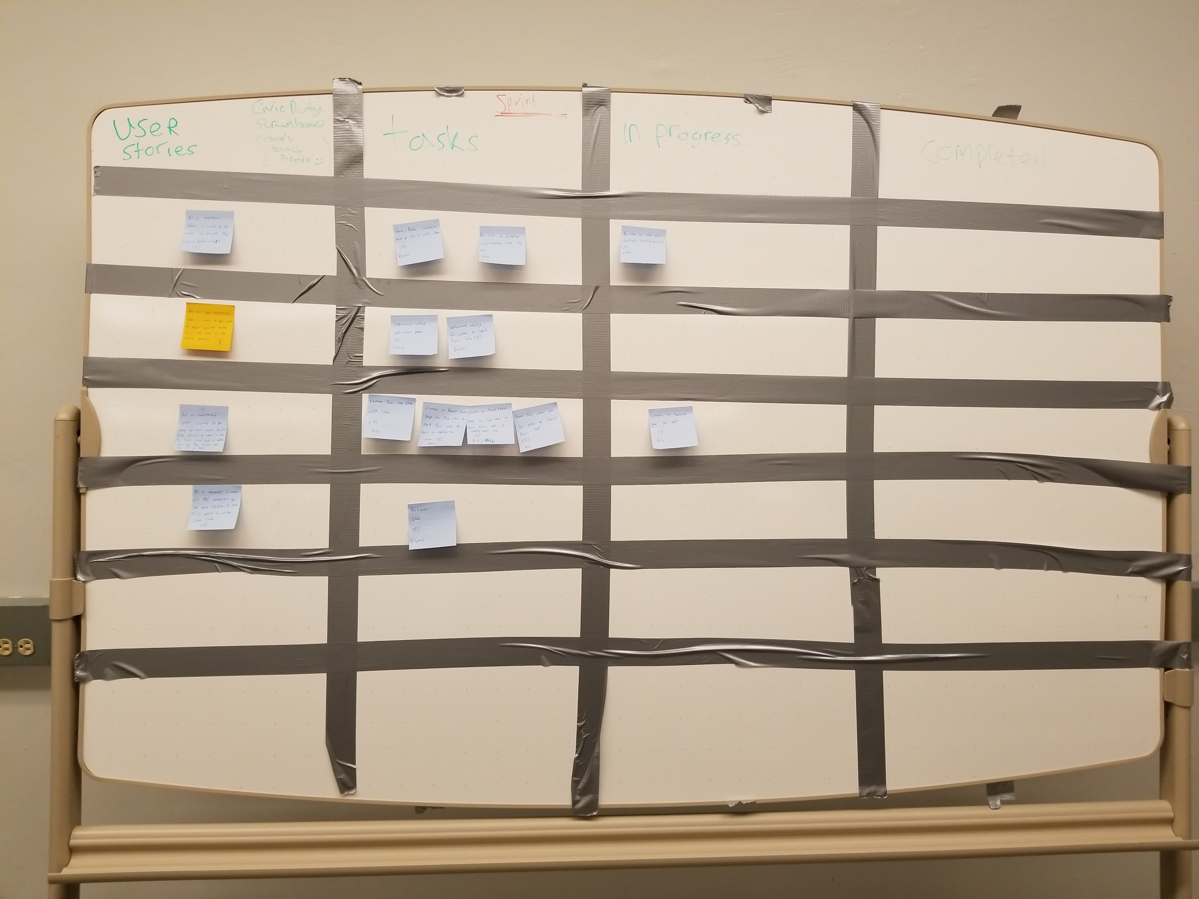

**Scrum Times:** Tuesday: 11 am, Thursday: 2 pm, Friday: 2 pm